**SMART HEALTH HUB: CLOUD-CONNECTED MEDICAL DISPENSER**

**A PROJECT REPORT**

***Submitted By***

**PIRANESSHARAN. TH (310820106040)**

**PRAVEEN KUMAR. P (310820106044)**

**SHAKIL AHAMED. M (310820106053)**

***in partial fulfillment for the award of the degree***

***of***

**BACHELOR OF ENGINEERING  
*in***

ELECTRONICS AND COMMUNICATION ENGINEERING

**JEPPIAAR ENGINEERING COLLEGE,**

**RAJIV GANDHI SALAI, CHENNAI-600119**

**ANNA UNIVERSITY:: CHENNAI 600 025**

MAY 2024

**ANNA UNIVERSITY : CHENNAI 600 025**

**BONAFIDE CERTIFICATE**

Certified that this project report “**SMART HEALTH HUB: CLOUD-CONNECTED MEDICAL DISPENSER**” is the bonafide work of “**PIRANESSHARAN. TH (310820106040), PRAVEEN KUMAR. P (310820106044), SHAKIL AHAMED. M (310820106053)”** who carried out the project under my supervision.

**SIGNATURE** **SIGNATURE**

Dr. J. JEBASTINE, M.E, Ph.D. Mrs. A. SAJITHA, M.E

**VICE- PRINCIPAL SUPERVISOR**

**HEAD OF THE DEPARTMENT** ASSISTANT PROFESSOR DEPARTMENT OF ELECTRONICS DEPARTMENT OF ELECTRONICS

& COMMUNICATION & COMMUNICATION

ENGINEERING ENGINEERING

JEPPIAAR ENGINEERING COLLEGE JEPPIAAR ENGINEERING COLLEGE

CHENNAI - 600 119 CHENNAI - 600 119

**CERTIFICATE OF EVALUATION**

|  |  |  |  |
| --- | --- | --- | --- |
| **S.NO.** | **Name of the student/s who have completed the project** | **Title of the Project** | **Name of the supervisor with the designation** |
| 01 | PIRANESSHARAN. TH (310820106040) | SMART HEALTH HUB: CLOUD–CONNECTED MEDICAL DISPENSER | MRS. A. SAJITHA, M.E. ASSISTANT PROFESSOR |
| 02 | PRAVEEN KUMAR. P (310820106044) |
| 03 | SHAKIL AHAMED. M (310820106053) |

The Reports of the project work submitted by the above students in partial fulfillment for the award of Bachelor of Engineering Degree in Electronics & Communication Engineering of Anna University, Chennai were confirmed to be reports of the work by the above students and then evaluated.

Signature for the Examination Held on: _____________________________

**INTERNAL EXAMINER EXTERNAL EXAMINER**

**ACKNOWLEDGEMENT**

We are very truly indebted to the **Late Col. Dr. Jeppiaar, M.A., B.L., Ph.D**, Founder, Jeppiaar Educational Trust, **Dr. Regeena J Murali, B.Tech., M.B.A., Ph.D**, Chairman and Managing Director, Principal **Dr. K. Senthil Kumar, M.E.**, **Ph.D, FIE, MISHREA, MISTE** and Vice-Principal **Dr. J. Jebastine, M.E, Ph.D**  for their blessings and the facilities to carry out the project.

We would like to express our gratitude to **Dr. J. Jebastine, M.E, Ph.D,** Professor and Head of the Department. We thank our project coordinator **Dr. J. Jebastine, M.E, Ph.D.** We thank our project co-coordinator **Dr. T.R. Chenthil, M.E, Ph.D**. We are thankful to our supervisor **Mrs. A. Sajitha, M.E**, for giving valuable suggestions and guiding us in all stages of the project.

We finally thank all the faculty members of the Department of Electronics and Communication Engineering for their constant support.

We would also like to thank our parents and friends for all their support and we thank the Almighty God for helping us complete this project successfully.

**ABSTRACT**

The Smart Health Hub (SHH) stands as a groundbreaking innovation poised to redefine medication management in healthcare settings and individual homes alike. This abstract explores the design, functionalities, and potential impact of SHH in optimizing medication adherence, enhancing patient safety, and reducing healthcare costs. The main aim is to illustrate a typical E-Pharmacy starting from a cloud that is connected to pharmacists, doctors, and patients. This enables the digital transfer of data online rather than the conventional method of buying medicines from pharmacies.

On this secured data transfer protocol patients can receive the proper medicines with clear prescriptions on time with transparent knowledge about the drugs they intake. The purpose of the experiment is to deliver the medicine to the customer in a minimum time. In our proposed system, the SHH machine will automatically dispense the tablet. In this project, one app is developed to describe the tablet's details, which acts as a prescription for the patients. Here, the doctor will prescribe the tablets using the app. This prescribed tablet detail is automatically stored in the Cloud. After that, the user needs to show the RFID card to the RFID reader. If the card is valid/ matched, the machine will automatically dispense the prescribed medicines. If the card is mismatched/invalid, an alert message will be sent to the user through the Blynk App. Over the 40 years in the pharmacy world, we come across a lot of malfunctions due to handwritten prescriptions and few pharmacies are still offering tablets without doctor’s prescriptions. If all the server data is synchronized with the single digital cloud the rate consumption variation of medical drugs can also be under control. If this system is achieved, we can get the global value of medicines in the market.

**TABLE OF CONTENTS**

|  |  |  |
| --- | --- | --- |
| **CHAPTER**  **NO** | **TITLE** | **PAGE NO** |
|  | **ABSTRACT**  **LIST OF FIGURES**  **LIST OF ABBREVIATION** | **v**  **x**  **xi** |
| **1** | **INTRODUCTION**  **1.1. SMART HEALTH HUB**  1.1.1. Terminology  1.1.2. Characteristics  1.1.3. Data Collections  1.1.4. Framework  1.1.4.1. Technology Framework  1.1.4.2. Human Framework  1.1.4.3. Institutional Framework  1.1.4.4. Energy Framework  1.1.4.5. Data Management Framework  1.1.5. Roadmap | **1**  **1**  1  2  4  4  5  5  6  6  6  7 |
| **2** | **LITERATURE REVIEW**  **2.1. INTRODUCTION**  **2.2. LITERATURE SURVEY**  2.2.1. Ashutosh D1. Gaur and Jasmin Padiya2, IJSR “A Study Impact of Digital India in Make in India‟ Program in IT and BPM Sector”, GLS University Transaction on Computer Science Engineering 2017.  2.2.2. A.Martina Franciska1 & Dr. S. Sahayaselvi2 IEEE “An overview on Digital Payment”, IJSCRT Transaction on Information Science Engineering 2019.  2.2.3. Aishwarya Raj Lakshmi1, and Ayaskanta Misra2 “RFID based Logistic Management System using IoT”, Research Gate Transactions on Neural Network, 2018.  2.2.4. Eric Becker1, Roman Arora2, and Vangelis Metsis3, “SmartDrawer: RFID-based smart medicine drawer for assistive environments”, Proceedings of the 2nd International Conference on Pervasive Technologies Related to Assistive Environments, January 2009.  2.2.5. Neethi1, Thammathip Piumsomboon2, Gun A. Lee2, and Mark Billinghurst2, Research Gate “A study of RFID Based Applications”, Research Gate Transactions on Augmented Reality in Computer Science Engineering, 2018.  2.2.6. Kubo1, A. Divija, G. V V N Vijayalakshmi, P. Vamsi, JARTMS “The Research of IoT based on RFID Tags”, IEEE explore Transactions on Reality and Web Interface, 2021.  2.2.7. Neeta Chavan, Isha Chavan, Saakshi Karkera, “Design And Development of Smart Pill Dispenser” Sardar Patel International Conference on Industry 4.0 - Nascent Technologies and Sustainability for 'Make in India' Initiative, 2022.  **2.3. MAJOR DISADVANTAGES TO OVERCOME** | **9**  **9**  9  9    10  11  12  12  14  15  **16** |
| **3** | **SYSTEM ANALYSIS**  **3.1. EXISTING SYSTEM**  **3.2. DISADVANTAGES OF THE EXISTING SYSTEM**  3.2.1. Capitalizing On Inconvenience  3.2.2. Potential Compounding Errors  3.2.3. Disadvantages Of Pharmacy Dispensing  **3.3. PROPOSED SYSTEM**  **3.4. ADVANTAGES OF THE PROPOSED SYSTEM**  3.4.1. Limitations  **3.5. APPLICATIONS** | **17**  **17**  **17**  18  18  19  **20**  **20**  **20**  **21** |
| **4** | **SYSTEM DESIGN**  **4.1. BLOCK DIAGRAM**  4.1.1. Smart Health Hub Side  4.1.2. Doctor’s Side  **4.2. SOFTWARE ALGORITHM** | **22**  **22**  22  23  **23** |
| **5** | **HARDWARE AND SOFTWARE DESCRIPTION**  **5.1. HARDWARE LIST**  5.1.1. ESP 32 Microcontroller  5.1.2. RFID System  5.1.3. RFID Reader  5.1.4. Servo Motor  5.1.5. Liquid Crystal Display(LCD)  5.1.6. Light Emitting Diode(s) (LED)  5.1.7. Buzzer  5.1.8. Push Buttons  5.1.9. Power Supply Unit  **5.2. SOFTWARE LIST**  5.2.1. Arduino IDE 1.8.19  5.2.2. Embedded C  5.2.3. MIT APP Inventor | **24**  **24**  24  24  25  25  26  26  26  27  27  **27**  27  28  29 |
| **6** | **RESULTS AND DISCUSSION**  **6.1. HARDWARE SETUP**  **6.2. SOFTWARE SETUP**  **6.3. FINAL RESULTS OBTAINED**  **6.4. COMPARISION BETWEEN EXISTING SYSTEM AND PROPOSED SYSTEM**  **6.5. CONCLUSION**  **6.6. FUTURE SCOPE** | **30**  **30**  **30**  **31**  **32**  **33**  **33** |
|  | **REFERENCES** | **34** |

**LIST OF FIGURES**

|  |  |  |
| --- | --- | --- |
| **FIGURE**  **NO** | **TITLE** | **PAGE**  **NO** |
| 1.1 | Bletchley Park is often considered to be the first smart community | 3 |
| 1.2 | Hong Kong Cyberport 1 and Cyberport 2 Buildings | 3 |
| 4.1 | Smart Health Hub Side | 22 |
| 4.2 | Doctor’s Application | 23 |
| 5.1 | ESP 32 Microcontroller | 24 |
| 5.2 | RFID System | 25 |
| 5.3 | RFID Reader | 25 |
| 5.4 | Servo Motor | 26 |
| 5.5 | 16*2 LCD | 26 |
| 5.6 | Buzzer | 27 |
| 5.7 | Screenshot of Arduino Ide showing the code for SHH | 28 |
| 5.8 | MIT App Inventor Interface | 29 |
| 6.1 | Prototype of the Proposed Model | 30 |
| 6.2 | patient_prescription App | 31 |
| 6.3 | Notifications From the Blynk App | 32 |

**LIST OF ABBREVIATIONS**

ESP - Espressif Systems

ICT - Information and Communications Technology

IDE - Integrated Development Environment

LCD - Liquid Crystal Display

LED - Light Emitting Diode

MIT - Massachusetts Institute of Technology

RFID - Radio Frequency IDentification

SHH - Smart Health Hub

**CHAPTER 1**

**INTRODUCTION**

* 1. **SMART HEALTH HUB**

A Smart Health Hub is a device that helps individuals manage their medication intake more effectively. It consists of a compartment system that stores various types of pills or doses. It integrates advanced features like automated dispensing, reminders, and connectivity options. It automates medication dispensing, eliminates manual sorting, and offers personalized schedules and dosage instructions. It also provides remote monitoring capabilities for caregivers and healthcare providers. Connectivity features enable real-time communication between users and healthcare providers. Security measures ensure medication storage safety. Smart health hubs aim to streamline medication management, reduce errors, and improve adherence rates, ultimately enhancing healthcare delivery and promoting better health outcomes for chronic conditions.

**1.1.1. Terminology**

Due to the breadth of technologies that have been implemented under the SHH label, it is difficult to distill a precise definition of a Smart Health Hub.

Deakin and Al Waer list four factors that contribute to the definition of a Smart Health Hub:

1. The application of a wide range of electronic and digital technologies to communities and Pharmacies.
2. The use of ICT to transform life and working environments within the region.
3. The embedding of such Information and Communications Technologies in government systems.
4. The territorialization of practices that bring ICT and people together to enhance the innovation and knowledge that they offer.

Deakin defines the SHH as one that utilizes ICT to meet the demands of the market (the citizens of the Pharmacy) and states that community involvement in the process is necessary for a smart Pharmacy.

A Smart Health Hub would thus be a Pharmacy that not only possesses ICT technology in particular areas but has also implemented this technology in a manner that positively impacts the local community.

**1.1.2. Characteristics**

It has been suggested that a smart pharmacy (also community, business cluster, urban agglomeration, or region) uses information technologies to:

1. Make more efficient use of physical infrastructure (roads, built environment, and other physical assets) through artificial intelligence and data analytics to support a strong and healthy economic, social, and cultural development.
2. Engage effectively with local governance officials by use of open innovation processes and e-participation, improving the collective intelligence of the Pharmacy’s institutions through e-governance, with emphasis placed on citizen participation and co-design.
3. Learn, adapt, and innovate and thereby respond more effectively and promptly to changing circumstances by improving the intelligence of the Pharmacy.
4. They evolve towards a strong integration of all dimensions of human intelligence, collective intelligence, and also artificial intelligence within the Pharmacy.

The intelligence of Pharmacy “resides in the increasingly effective combination of digital telecommunication networks (the nerves), ubiquitously embedded intelligence (the brains), sensors and tags (the sensory organs), and software (the knowledge and cognitive competence.



***figure 1.1. Bletchley Park is often considered to be the first smart community***

1. **Orchestration intelligence:** Where Pharmacy establishes institutions and community-based problem-solving and collaborations, such as in Bletchley Park, where the Nazi Enigma cipher was decoded by a team led by Alan Turing. This has been referred to as the first example of a smart Pharmacy or an intelligent community.
2. **Empowerment intelligence:** Pharmacy provides open platforms, experimental facilities, and smart Pharmacy infrastructure to cluster innovation in certain districts. These are seen in the Kista Science Pharmacy in Stockholm and the Cyberport Zone in Hong Kong. Similar facilities have also been established in Melbourne and Kyiv.

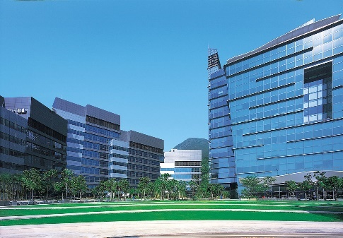

***figure 1.2 Hong Kong Cyberport 1 and Cyberport 2 Buildings***

1. **Instrumentation Intelligence:** Where Pharmacy infrastructure is made smart through real-time data collection, with analysis and predictive modelling across Pharmacy districts. There is much controversy surrounding this, particularly about surveillance issues in smart Pharmacy. Examples of Instrumentation intelligence are those implemented in Amsterdam. This is realized through:
2. A common IP infrastructure that is open to researchers to develop applications.
3. Wireless meters and devices transmit information at the point in time.
4. Several homes are being provided with smart energy meters to become aware of energy consumption and reduce energy usage.
5. Solar power garbage compactors, car recharging stations and energy-saving lamps.

**1.1.3. Data Collections**

Smart Pharmacy is a system that connects a pharmacy’s public infrastructure with application systems, collecting data through three layers: the perception layer, the network layer, and the application layer. Data is collected through sensors like cameras, RFID, or GPS, and sent to the network layer via wireless transmissions. The network layer transports collected data to the application layer, which processes it to make decisions on controlling the pharmacy infrastructure. The application layer is responsible for keeping collected data private and ensuring data security.

**1.1.4. Framework**

The creation, integration, and adoption of smart Pharmacy capabilities require a unique set of frameworks to realize the focus areas of opportunity and innovation central to smart Pharmacy projects. The frameworks can be divided into 5 main dimensions which include numerous related categories of smart Pharmacy development:

**1.1.4.1. Technology Framework**

A smart pharmacy relies on various technological infrastructures to interact with human and technological systems. Digital pharmacies combine broadband communications, flexible computing, and innovative services to meet the needs of governments, employees, citizens, and businesses. Cognitive technologies like artificial intelligence and machine learning can be trained on data generated by connected pharmacy devices to identify patterns and quantify policy decisions. Ubiquitous pharmacies provide access to public services through any connected device, extending the concept of digital pharmacy. Wired pharmacies support IoT and wireless technologies, providing access to continually updated digital and physical infrastructure. Hybrid pharmacies combine physical conurbation with virtual pharmacy, allowing for future-state projects for smart pharmacy services and integration. Information pharmacy is crucial for interpreting and storing large amounts of data generated by interactive devices in a smart pharmacy, ensuring growth and security.

**1.1.4.2. Human Framework**

Smart Pharmacy initiatives significantly improve citizens’ quality of life by focusing on the human framework, including the economy, knowledge networks, and human support systems. Creative initiatives, such as arts and culture, foster intellectual curiosity and creativity. Education initiatives build a capable workforce, ensuring mobility and cultural exchange. Soft infrastructure development, such as voluntary organizations and safe zones, promotes diversity, inclusion, and ubiquitous access to public services. Knowledge economy development is central to Smart Pharmacy projects, emphasizing the value of innovation in fostering economic activity in emerging tech and service sectors.

**1.1.4.3. Institutional Framework**

Since the 1990s, the smart community movement has aimed to expand the number of IT users and collaborate with the government and other organizations to improve daily life quality. A smart community deploys technology to solve social and business needs, but institutional involvement is crucial for the success of these initiatives. Smart growth is essential for addressing issues like traffic congestion, school overcrowding, and air pollution. Technological advancements are not an end in themselves, but rather a means to reinvent pharmacy for a new economy and society. Government support is necessary for the success of smart pharmacy initiatives. A smart pharmacy is considered smart when investments in human/social capital and IT infrastructure fuel sustainable growth and enhance quality of life through participatory governance.

**1.1.4.4. Energy Framework**

Smart Pharmacy utilizes data and technology to improve efficiency, sustainability, economic development, and quality of life. It integrates technology across IoT sectors, enabling self-sustaining areas or Positive Energy Districts. Smart Pharmacy uses smart connections for street lighting, buildings, distributed energy resources, data analytics, and transportation. Utility companies, along with technology companies, are key players in accelerating the growth of America’s smart Pharmacy.

**1.1.4.5. Data Management Framework**

Smart Pharmacy employs a combination of data collection, processing, and disseminating technologies in conjunction with networking and computing technologies and data security and privacy measures encouraging the application of innovation to promote the overall quality of life for its citizens and covering dimensions that include: utilities, health, transportation, entertainment and government services.

**1.1.5. Roadmap**

A smart Pharmacy roadmap consists of four/three (the first is a preliminary check) major components

1. **Define exactly what the community is:** maybe that definition can condition what you are doing in the subsequent steps; it relates to geography, links between Pharmacy and countryside, and flows of people between them; maybe – even – that in some countries the definition of Pharmacy/community that is stated does not correspond effectively to what – in fact – happens in real life.
2. **Study the Community:** Before deciding to build a smart Pharmacy, first we need to know why. This can be done by determining the benefits of such an initiative. Study the community to know the citizens, the business’s needs – know the citizens and the community’s unique attributes, such as the age of the citizens, their education, hobbies, and attractions of the Pharmacy.
3. **Develop a smart Pharmacy Policy**: Develop a policy to drive the initiatives, where roles, responsibilities, objectives, and goals, can be defined. Create plans and strategies on how the goals will be achieved.
4. **Engage The Citizens**: This can be done by engaging the citizens through the use of e-government initiatives, open data, sports events, etc.

In short, People, Processes, and Technology (PPT) are the three principles of the success of a smart Pharmacy initiative. Pharmacy must study their citizens and communities, know the processes, and business drivers, create policies, and objectives to meet the citizens’ needs. Then, technology can be implemented to meet the citizens’ needs, to improve the quality of life and create real economic opportunities. This requires a holistic customized approach that accounts for Pharmacy cultures, long-term Pharmacy planning, and local regulations.

“Whether to improve security, resiliency, sustainability, traffic congestion, public safety, or Pharmacy services, each community may have different reasons for wanting to be smart. But all smart communities share common attributes—and they all are powered by smart connections and by our industry’s smarter energy infrastructure. A smart grid is a foundational piece in building a smart community.” – Pat Vincent-Collawn, chairman of the Edison Electric Institute and president and CEO of PNM Resources.

**CHAPTER 2**

**LITERATURE REVIEW**

**2.1. INTRODUCTION**

The following shows a survey done for Smart Health Hub and its importance to the social network. Here on the deep analysis, we came to know the various levels of methods being handled by the Drug companies to sell their drugs at differential price tags based on the needs of the common man in the society. Further study was extended to make a detailed survey on how the software system was developed for stock maintenance and refilling of goods. Existing software and systems have touched to some extent when compared to the digital world.

**2.2. LITERATURE SURVEY**

**2.2.1. Ashutosh D1. Gaur and Jasmin Padiya2, IJSR “A Study Impact of Digital India in Make in India‟ Program in IT and BPM Sector”, GLS University Transaction on Computer Science Engineering 2017.**

The Digital India Program was launched by Prime Minister Narendra Modi on July 1, 2015. In the inaugural speech of this program, he mentioned his dream of a digital India i.e. for driving innovation, knowledge is strength and empowers the people, access to information knows no barrier, the government is open & governance is transparent, technology ensures quietly.

The citizen-government interface is incorruptible, governmental services are easy and efficiently available to citizens on mobile devices, government productivity engaged with people through social media, quality education reaches the most inaccessible corners driven by digital learning, quality health care percolates right up to the remotest region powered by e-health care, formers are developed.

The huge empowered with real-time information to the connected with global market, mobile enable emergency services ensures personal security, cyber security is an integral part of national security, mobile & e-banking ensures financial inclusion, e-commerce drive entrepreneurship, the world looks to India for next big idea, etc.

Digital India attracted more than 4lakh crore investment and generated more than eighteen lakh job opportunists at its launch. The second highest import category in India is electronics goods in the country. This fact is indigestible because India has the largest number of IT professionals and very large MSME (Micro, Small, and Medium) scoter still it has not developed its capabilities to manufacture in this sector. The government has made the policy with a vision to make net zero import of this category. This aim will be achieved by the Make in India and Digital India program to boost manufacturing and increase domestic demand.

Digital India (Ministry of Electronics & Information Technology, Government of India, 2016) “The Digital India programme is a flagship programme of the government of India with a vision to transform India into a digitally empowered society and knowledge economy”.

**2.2.2. A.Martina Franciska1 & Dr. S. Sahayaselvi2 IEEE “An overview on Digital Payment”, IJSCRT Transaction on Information Science Engineering 2019.**

Information Technology (IT) has revolutionized the various aspects of our lives; particularly it has provided an easy way to go for digital payments. During the Demonetization period, the Government of India forced the people directly or indirectly to do all commercial transactions via Digital mode. The common people started to move from traditional payment systems towards Digital Payments systems which ensured safety, security, and convenience.

With Giant technological leaps in the smartphone and easy internet access has led Indian market to accept Digital Payments. The percentage of digital payments through other modes is also increasing in a significant speed. The objective of the present study is to know about the various types of Digital payment transactions that are used by the common people in their day-to-day lives. This study is chiefly based on Secondary data. The result indicates that the Digital revolution has made cashless transactions an easy one. As a result in 2015-2016, a total of 4018 billion has been transacted through mobile banking when compared to 60 billion in 2012-13. The reach of mobile networks, the Internet, and electricity is also expanding digital payments to remote areas. So, it Is without doubt said that the future transaction system is a cashless transaction.

**2.2.3. Aishwarya Raj Lakshmi1, and Ayaskanta Misra2 “RFID based Logistic Management System using IoT”, Research Gate Transactions on Neural Network, 2018.**

In this modern era, technology is important for the success of an industry, as the market is more volatile, understanding the customer base and forecasting of demand has become more complex.

This has pushed the companies to address the gap through various software applications and a review has been done to evaluate the feasibility of IoT in the area of Logistic Management.

Here things refer to the unique identity of remote sensing, monitoring, and self-configuring. IoT technology and business strategy have influences on the process of business and selected IoT application as it implies the interaction between the digital and real world. Before reaching the customer, products should cross multiple business partners to have the right information about the identity, location, and other tracking information. This study helped us to bring the need for it in Transportation. Also, there should balance of time and money.

This is done by RFID which makes the company aware of, where is the product. The main intention to develop a multimodality system is that it can be used for various applications.

**2.2.4. Eric Becker1, Roman Arora2, and Vangelis Metsis3, “SmartDrawer: RFID-based smart medicine drawer for assistive environments”, Proceedings of the 2nd International Conference on Pervasive Technologies Related to Assistive Environments, January 2009.**

Radio Frequency Identification (RFID) is an emerging technology, being used in monitoring including healthcare. We apply different types of RFID tags to monitor drug taking and its impact in an assistive environment.

Compared to other active Wireless Sensor Networks (WSNs), RFID tags do not need a battery, or recharging, and so have no battery power loss problems. RFID tags are tiny in volume and can be embedded into different objects.

This paper talks about an RFID-based application in an assistive environment called “Smart Drawer”, which tracks medicine taking for the elderly.

We investigate the hardware involved in building such an application and we develop the software infrastructure to create a functional system to assist patients and caregivers with medication procedures and also collect data for future use.

**2.2.5. Neethi1, Thammathip Piumsomboon2, Gun A. Lee2, and Mark Billinghurst2, Research Gate “A study of RFID Based Applications”, Research Gate Transactions on Augmented Reality in Computer Science Engineering, 2018.**

Radio Frequency Identification (RFID) is a promising technology for process automation and beyond that capable of identifying objects without the need for a line of sight. However, the trend toward automatic identification of objects also increases the demand for high-quality RFID applications. Therefore, research on testing RFID systems and methodical approaches for testing are needed. This thesis presents a novel methodology for the system-level test of RFID applications. The approach called ITERA allows for the automatic generation of tests, defines a semantic model of the RFID system, and provides a test environment for RFID applications.

The method introduced can be used to gradually transform use cases into a semi-formal test specification. Test cases are then systematically generated, to execute them in the test environment. It applies the principle of model-based testing from a black-box perspective in combination with a virtual environment for automatic test execution. The presence of RFID tags in an area, monitored by an RFID reader, can be odelled by time-based sets using set-theory and discrete events. Furthermore, the proposed description and semantics can be used to specify RFID systems and their applications, which might also be used for other purposes than testing.

The approach uses the Unified Modelling Language to model the characteristics of the system under test. Based on the ITERA Meta model test execution paths are extracted directly from activity diagrams and RFID-specific test cases are generated. The approach introduced in this thesis allows us to reduce the efforts for RFID application testing by systematically generating test cases and the automatic test execution. In combination with the Meta model and by considering additional parameters, like unreliability factors, it not only satisfies functional testing aspects but also increases the confidence in the robustness of the tested application. Mixed with the Instantly available virtual readers, it has the potential to speed up the development process and decrease the costs – even during the early development phases.

ITERA can be used for highly automated testing, reproducible tests, and because of the instantly available readers, even before the real environment is deployed. Furthermore, the total control of the RFID environment enables to testing of applications that might be difficult to test manually. This thesis will explain the motivation and objectives of this new RFID application test methodology. Based on an RFID system analysis it proposes a practical solution to the identified issues. Further, it gives a literature review on testing fundamentals, model-based test case generation, the typical components of an RFID system, and RFID standards used in the industry.

**2.2.6. Kubo1, A. Divija, G. V V N Vijayalakshmi, P. Vamsi, JARTMS “The Research of IoT based on RFID Tags”, IEEE explore Transactions on Reality and Web Interface, 2021.**

The Internet of Things is the third wave of the global information industry following computers, the Internet, and mobile communication networks. The International Telecommunication Union proposes four key application technologies of IoT: RFID technology, sensor technology, smart technology, and Nanotechnology. RFID technology, which is short for radio frequency identification, is introduced in this paper. The background, connotation, and architecture of IoT is first presented, then is the RFID technology, including its components, principles, and standards. Based on it, applications of IoT systems based on RFID technology are presented, such as product line and logistics management, food security supervision, hospital assets, personnel and container management, and monitoring for miners. Among these, the EPC IoT system is specially outlined, which is composed of RFID hardware, Savant middleware and the Internet system. Lastly, the development of RFID technology in our country is presented. Although there are some difficulties at present, we believe that RFID technology will be further developed and innovated to provide more convenient services for users in the future.

**2.2.7. Neeta Chavan, Isha Chavan, Saakshi Karkera, “Design And Development of Smart Pill Dispenser” Sardar Patel International Conference on Industry 4.0 - Nascent Technologies and Sustainability for 'Make in India' Initiative, 2022.**

This paper proposes a unique plan to produce reminders and automatically dispense medicines for patients at the right dosage time. Nowadays, many people may not remember to take their medicines as per instructions given by medical professionals due to mental stress. Consequently, the disease will take a long time to recover. Sometimes, aged patients are gulping tablets, and their indefinite quantity level incorrectly causes a severe drawback. Therefore, the patient should take the correct medicines in prescribed quantities and time. To beat these issues, a unique Smart Pill Dispenser system is projected. This method uses Microcontroller, LCD, and Real-Time clock (RTC) module, Buzzer. This transportable and economical prototype of the Smart Pill Dispenser system would facilitate aged patients, particularly illiterate patients. Gerontology recognises that taking pharmaceuticals helps seniors to maintain their health, but convoluted medication schedules can lead to errors like missing doses, taking too much medication, or taking it at the wrong time. These errors may result in more medical or hospital visits, illness, or even death. In order to help older people take their medications on time, it is desirable to design a medication dispensing device. This could prevent unwanted hospital or doctor visits brought on by the misuse of medications. This paper suggests a design for a smart gadget that delivers medication in accordance with the recommended timetable. This device can be further modified and interface with the web application by implementing Internet of Things.

**2.3. MAJOR DISADVANTAGES TO OVERCOME**

One of the biggest disadvantages of the online pharmacy model is the lack of physical evaluation capacity. In some cases, physical evaluations can be made and situation analysis can be done very effectively. Even if the online evaluation process is done, this process will not be done by licensed healthcare professionals. One of the disadvantages of E-Pharmacy is that there is no one you can contact face to face.

When patients want to ask questions about the drugs they are taking, it is very difficult for them to reach a licensed pharmacist. For this reason, it may not be possible for patients to access their medication on the same day. Some online pharmacies can dispense medicines to patients without requiring a prescription. In such a case, patients can get sick much more severely instead of healing. Therefore, when buying drugs from the pharmacy, pharmacists must request a prescription. Some illegal online pharmacies sell over-the-counter drugs by putting human health at risk, and it is very difficult to prevent this.

One of the issues that raise questions about the E-Pharmacy application is the privacy of personal and financial information. Therefore, online pharmacies should create their privacy policy pages on their websites and ensure that personal information and financial information are not shared with third parties.

**CHAPTER 3**

**SYSTEM ANALYSIS**

**3.1. EXISTING SYSTEM**

Pharmacy is the branch of medical science that deals with the study of drugs (Medicine). The persons who own the pharmacy must be a citizens of India between the ages of 18 – 60. He is responsible for the proper quality of the drugs dispatched to the customers. We know that without the prescription of doctors, pharmacists are not allowed to distribute the medicines to the common people, still we could able to see some uncivilized people approach pharmacies to get direct medicines.

Since they distribute the medicines to those persons without billing it is considered as a false act in the file of medical science. This long-term practice can be eliminated with our project and its guidelines. In addition, people cannot wait in a queue line for a longer period. Due to digital processing, all the data handling and dispatching processes will be much faster when compared to the existing system.

**3.2. DISADVANTAGES OF THE EXISTING SYSTEM**

If you ask any of your patients why they do not like going to the pharmacy, they are likely to give you an extensive list of the disadvantages of pharmacy dispensing. Some patients may claim they do not like the time and effort it takes from when they receive the prescription to when they receive their medication. Others may report they don’t like everyone else in the pharmacy line being able to hear or see their transactions.

Patients do not ask for much when it comes to their health. They want you to help them relieve negative symptoms. They want their privacy protected.

They want quick service and they want all of this at the lowest price possible. Pharmacies do not seem to take any of these factors into consideration. Not necessarily because they are mean or don’t want to help, but pharmacists are busy. They are too busy to put the patient first. Keep reading to find out the most common disadvantages of pharmacy dispensing.

**3.2.1. Capitalizing on Inconvenience**

Studies have shown that patients are not satisfied with pharmacies, especially chain pharmacies. Much of their dissatisfaction is due to the amount of time patients spend waiting to receive their medicine. During this wait time, patients end up spending too much money on items they do not need. Pharmacies are set up to up-sell products that could be purchased for much less at the dollar store. Patients get bored, however, and to kill time they shop. Pharmacies capitalize on the wait time of patients. Also, the longer the time at the pharmacy, the longer a patient must wait for relief. When someone is in pain, they will do almost anything for relief, even if temporary. This includes impulse shopping.

**3.2.2. Potential Compounding Errors**

A medication error is defined as any event that can be prevented but due to error on the part of the physician, pharmacist or patient, causes harm to the patient. Pharmacy errors are increasing each year. Medication errors can include the following: giving the patient the wrong medication; giving the patient someone else’s medication; pharmacist authorizing the wrong dose on the medication; pharmacist or pharmacy technician contaminating the medication. These errors happen, and they happen regularly across the country. The use of pharmaceutical technicians is also a concern. They are not trained as well to spot errors, prevent cross-contamination, and keep up with the enormous demands of busy pharmacies today, which are major disadvantages of pharmacy dispensing. During a recent flu epidemic, when drug stores ran out of Tamiflu, the FDA simply posted their recipe and instructed pharmacists to recreate the formula as they needed it. This tactic led to major medical issues for patients and even killed some. Accidents like these can lead to allergic reactions in patients who trust the pharmacist to get it right. An overdose can happen when a patient takes a higher dose of a medication than they should have. An overdose can also happen when a patient takes the wrong medicine, thinking it is the right medicine. Furthermore, an overdose can happen when a patient takes too many medications.

**3.2.3. Disadvantages of Pharmacy Dispensing**

It’s tempting for patients to seek advice from pharmacists. They think because they work with medications, pharmacists should know how to direct them when they have a problem. While pharmacists can offer their opinions and yes, they are well educated on the prescription medicines they fill, they are not the right person to recommend treatment options for patients. Pharmacists are not trained like physicians to offer treatment options, and they would not want to risk their license in doing so. Pharmacists can, however, explain in detail the medication or treatment you have been prescribed. For example, if a patient is prescribed an anti-depressant, pharmacists can consult with the patient on everything related to that anti-depressant. This can include side effects and what to do in case of an accidental overdose. This same pharmacist, even if they feel the patient has been given poor medication, cannot explain all other treatment options to a patient. They can simply refer them back to their physician which is another of the disadvantages of pharmacy dispensing. Other disadvantages of pharmacy dispensing include the possibility of cross-contamination if medications are compounded on unclean surfaces. Or, if staff members are sick with the flu or other illnesses and are not following safe handling procedures. Patients do not want to deal with the disadvantages of pharmacy dispensing and many more. Providing them with services such as in-office dispensing turns these disadvantages into advantages. It also turns patients into happy, satisfied, and loyal customers. When you have loyal patients, your practice will thrive.

**3.3. PROPOSED SYSTEM**

In our project, we are using an ESP32, LCD, RFID card, RFID reader, button, two LEDs, and servo motor. The power supply unit is used to power up the circuit.

RFID Reader read is used to read the tag value. LCD is used to display the tablet details. A button is used to give the payment details.

A Servo motor is used to dispense the tablets. Two LEDs green and red indicate whether a successful payment is done or not. In this project, one app is developed to describe the tablet’s details which is named “Patient Prescription”, which is accessed by doctors only for adding the tablet details.

The prescribed tablet details are stored in the IoT. After that, the prescription is provided, the user needs to show the RFID card to the RFID reader. If the card is matched, the machine will automatically dispense the prescribed medicines. If the card is invalid, the buzzer would alarm and an alert notification is received through the Blynk application.

**3.4. ADVANTAGES OF THE PROPOSED SYSTEM**

1. The project automates medication dispensing using RFID card authentication, improving efficiency and accuracy.
2. It eliminates manual verification and interaction with medical staff.
3. Real-time monitoring and notifications are provided through the Blynk application. The IoT-stored tablet information enhances decision-making and patient care.
4. RFID card authentication reduces medication theft and misuse.
5. The system is user-friendly with an LCD and payment button.
6. The project can be adapted for various healthcare settings and scales to accommodate larger facilities or patient populations.

**3.4.1. Limitations**

The system requires internet connectivity, 24/7 power backup, and safety measures for loyalty cards. Manual data entry is necessary for system failures. Surveillance is necessary for security. Additional service tax is distributed for maintenance. Despite these expenses, globalization could reduce medicine prices by half due to avoiding middleman robbery.

**3.5. APPLICATIONS**

Digitalization has been one of the most important trends in India over the past few years. This rapid growth helps propel India to the forefront of digital and technological innovation, particularly by leveraging the energies of the country’s young population. We strongly believe that our proposal would be a valuable key in digitalization. Medical standards can be increased in our nation by following our few principles our proposed system can also boost the GDP of our nation to some extent. Our system must be upgraded to bio-medical scanning devices. This can create high security and avoid false play. Online and UPI money portals must be introduced to the system. Through this transaction portal service, our system can be even more robust. A general awareness medical log about the prescription must be added to the digital prescription. This can create huge awareness among the public on medical drugs and their causes.

**CHAPTER 4**

**SYSTEM DESIGN**

**4.1. BLOCK DIAGRAM**

**4.1.1. Smart Health Hub Side**

The ESP32 microcontroller is the central component of this system, controlling various peripherals and functionalities. It connects to RFID cards, RFID readers, buttons, LEDs, IoT devices, servo motors, buzzers, LCD displays, and an external power supply. The ESP32 facilitates RFID communication, user input, LED feedback, motor control, and display interaction. The system communicates with an LCD display for user interaction. The ESP32 ensures the necessary voltage for the system.

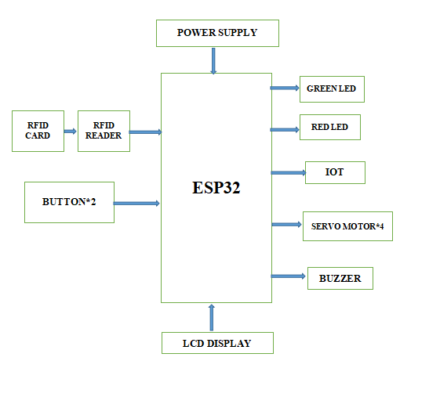

***figure 4.1. Smart Health Hub Side***

**4.1.2. Doctor’s Side**

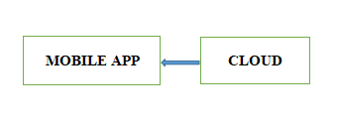

***figure 4.2. Doctor’s Application***

**4.2. SOFTWARE AND ALGORITHM**

Embedded C is a programming language used for developing software for embedded systems, which are specialized computing systems used in various applications. The development process typically involves writing code in C or C++, as these languages provide low-level access to hardware and are suitable for resource-constrained environments.

Embedded C is a variant of the C programming language, optimized for use in embedded systems. Key concepts related to embedded C programming include understanding hardware, writing code, compiling, linking, debugging, optimization, testing, and validation.

Developers must have a deep understanding of the hardware, including microcontrollers, sensors, actuators, and communication interfaces. The code is then compiled into machine code that the microcontroller can execute using a specific compiler. The code is then linked into a single executable file, resolving external references and generating the final binary image. Debugging is challenging due to limited debugging tools and limited resources.

**CHAPTER 5**

**HARDWARE AND SOFTWARE DESCRIPTION**

**5.1. HARDWARE LIST**

**5.1.1. ESP 32 Microcontroller**

The ESP32 microcontroller is the central component of this system, controlling various peripherals and functionalities. It connects to RFID cards, RFID readers, buttons, LEDs, IoT devices, servo motors, buzzers, LCDs, and an external power supply. The ESP32 facilitates RFID communication, user input, LED feedback, motor control, and display interaction. The system communicates with an LCD for user interaction. The ESP32 ensures the necessary voltage for the system.

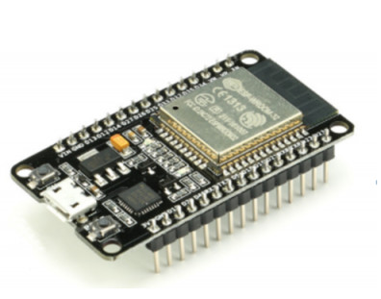

***figure 5.1. ESP 32 Microcontroller***

**5.1.2. RFID System**

RFID (Radio Frequency IDentification) is an automated data collection (ADC) technology that uses radio waves to read and capture information on a tag attached to an object. It can be read from several feet away and does not require direct line-of-sight. RFID is fast, low-cost, and offers unique identification and backend integration for a wide range of applications. Other ADC technologies include bar codes and OCR. An RFID system consists of an antenna, transceiver, and transponder, with the transponder activating when a signal is transmitted by the tag.

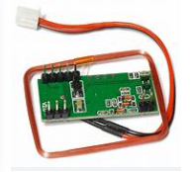

***figure 5.2. RFID System***

**5.1.3. RFID Reader**

A radio frequency identification **reader** (**RFID reader**) is a device used to gather information from an **RFID** tag, which is used to track individual objects. Radio waves are used to transfer data from the tag to a **reader**.

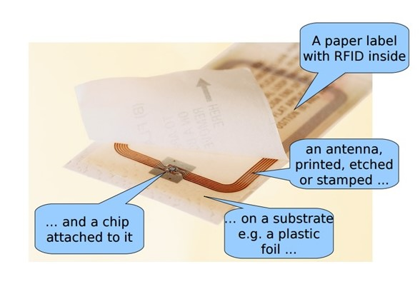

***figure 5.3. RFID Reader***

**5.1.4. Servo Motor**

Servo implies an error-sensing feedback control that is utilized to correct the performance of a system. It also requires a generally sophisticated controller, often a dedicated module designed particularly for use with servomotors. Servo motors are DC motors that allow for precise control of the angular position. They are DC motors whose speed is slowly lowered by the gears. The servo motors usually have a revolution cut-off from 90° to 180°. A few servo motors also have a revolution cutoff of 360° or more. But servo motors do not rotate constantly. Their rotation is limited between the fixed angles.

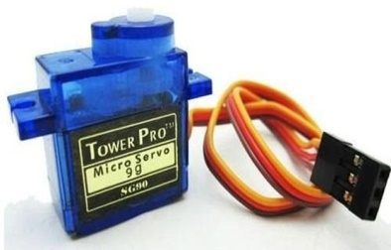

***figure 5.4. Servo Motor***

**5.1.5. Liquid Crystal Display**

A liquid crystal display (LCD) is a thin, flat electronic visual display that uses the light-modulating properties of liquid crystals (LCs). It is used in various applications, including computer monitors, televisions, instrument panels, and aircraft cockpit displays. Each pixel in an LCD consists of molecules aligned between two transparent electrodes and two polarizing filters. The electrodes are made of Indium Tin Oxide (ITO) and are treated to align the molecules in a specific direction. The orientation of the molecules is determined by the alignment at the electrodes, resulting in a grey or black display.

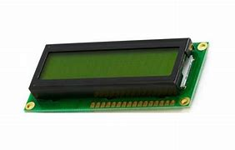

***figure 5.5. 16*2 LCD***

**5.1.6. Light Emitting Diode(s) (LED)**

A semiconductor device that emits light when an electric current passes through it. LEDs are a type of solid-state lighting, meaning they convert electricity into light using the movement of electrons within a semiconductor material.

**5.1.7. Buzzer**

A buzzer or beeper is an audio signaling device, which may be mechanical, electromechanical, or piezoelectric (piezo for short). Typical uses of buzzers and beepers include alarm devices, timers, and confirmation of user input such as a mouse click or keystroke.

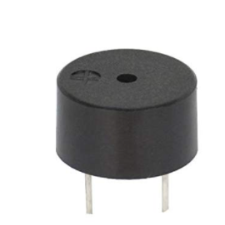

***figure 5.6. Buzzer***

**5.1.8. Push Buttons**

Push buttons are open tactile switches that power circuits or make connections by pressing them. They are common in daily electronic equipment and trigger SCR by gate terminal.

**5.1.9. Power Supply Unit**

12v DC adapter is used (i.e. it has to put out DC, not AC)

12v is converted into 5v DC by using a voltage regulator. This 5v power supply is used in this circuit for its operation.

**5.2. SOFTWARE LIST**

**5.2.1. Arduino IDE 1.8.19**

The Arduino IDE is a cross-platform Java programming application for Microsoft Windows, macOS, and Linux. Originating from the Processing and Wiring IDE, it features a code editor, message area, text console, toolbar, and hierarchy of operation menus. The IDE supports C and C++ languages and provides a software library from the Wiring project. User-written code requires two basic functions: starting the sketch and the main program loop. The IDE converts the executable code into a text file in hexadecimal encoding, which is loaded into the Arduino board by a loader program in the board's firmware. The source code is released under the GNU General Public License, version 2.

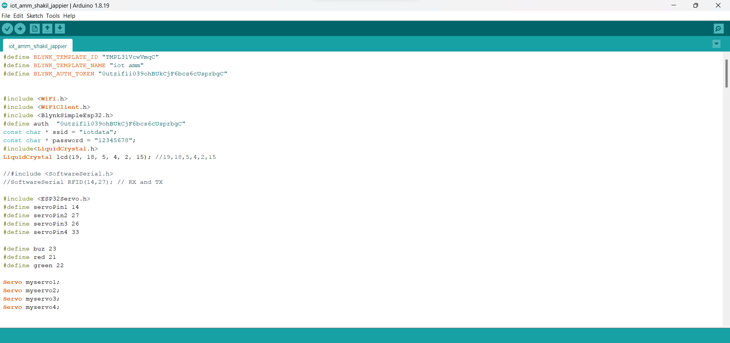

***figure 5.7. Screenshot Arduino IDE showing the code for SHH***

**5.2.2. Embedded C**

Embedded C is a programming language commonly used for developing software for embedded systems, which are specialized computing systems designed to perform dedicated functions within larger devices or systems. These systems can be found in a wide range of applications, from consumer electronics like smartphones and digital cameras to industrial machinery, automotive systems, and medical devices. The software development process for embedded systems typically involves writing code in C or C++, as these languages provide low-level access to hardware and are well-suited for resource-constrained environments. Embedded C is a variant of the C programming language, optimized for use in embedded systems.

**5.2.3. MIT App Inventor**

MIT App Inventor (App Inventor or MIT AI2) is a high-level block-based visual programming language, originally built by Google and now maintained by the Massachusetts Institute of Technology. It allows newcomers to create computer applications for two operating systems: Android and Ios, which, as of 25 September 2023, are in beta testing. It is free and open-source and released under dual licensing: a Creative Commons Attribution ShareAlike 3.0 Unported license and an Apache License 2.0 for the source code. Its target is primarily children and students studying computer programming, similar to Scratch. The web interface consists of a graphical user interface (GUI) very similar to Scratch and StarLogo, allowing users to drag-and-drop visual objects to create an application that can be tested on Android and Ios devices and compiled to run as an Android app. It uses a companion mobile app named MIT AI2 Companion providing live testing and debugging.

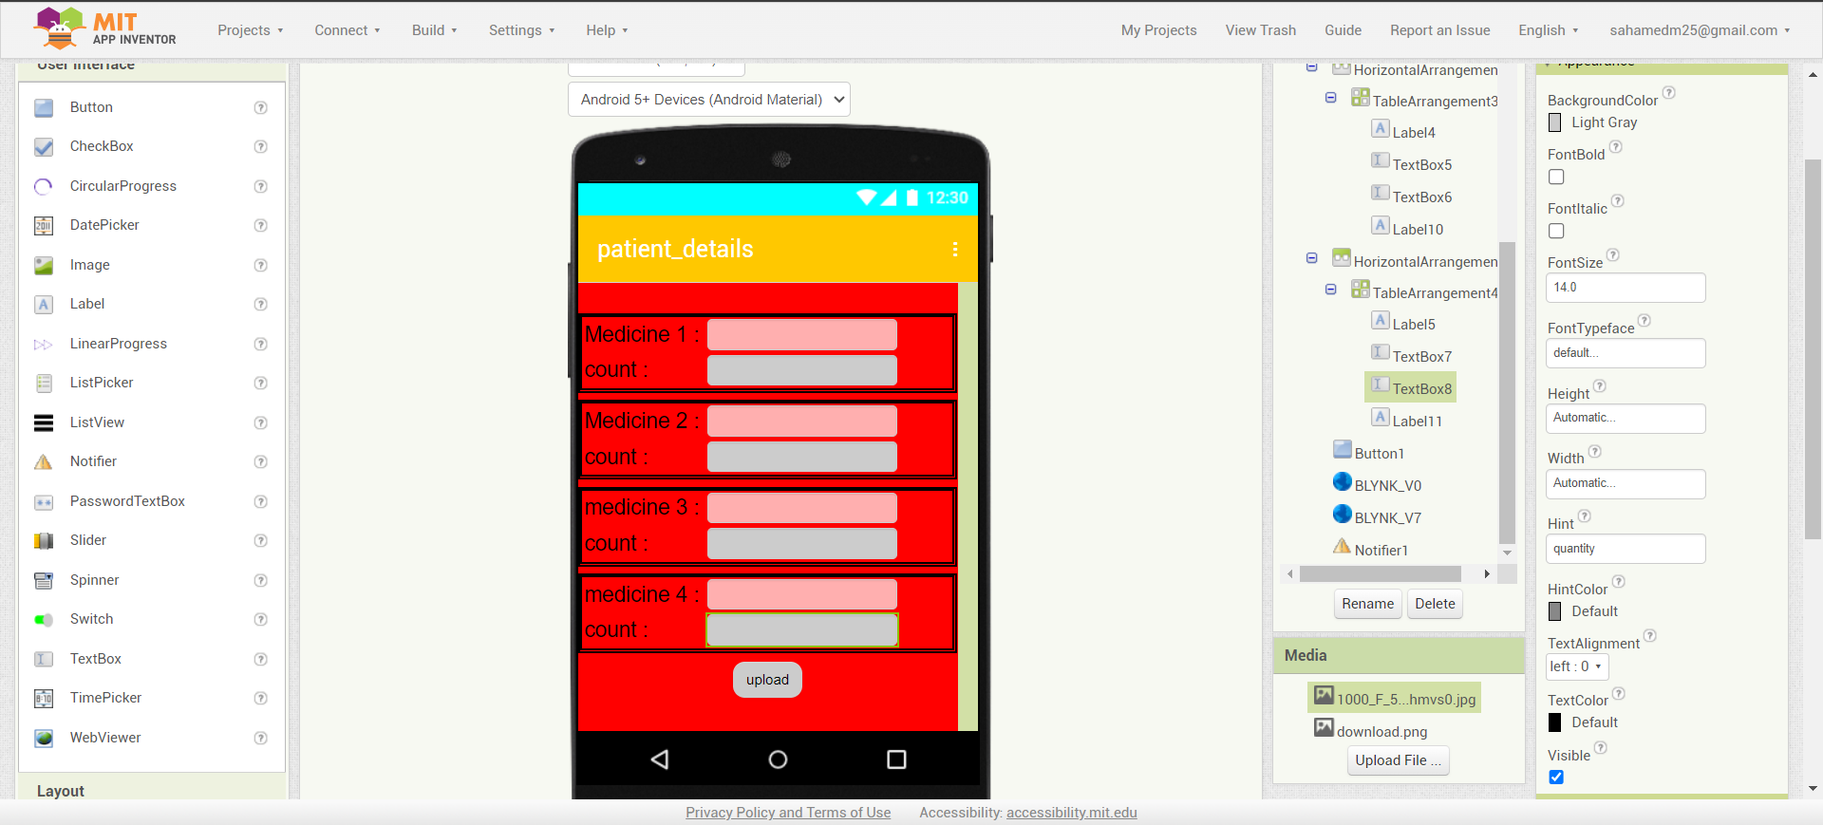

***figure 5.8. MIT APP Inventor***

**CHAPTER 6**

**RESULTS AND DISCUSSION**

**6.1. HARDWARE SETUP**

The result description of our project consists of both hardware and software. The experimental results obtained in this project work are discussed here.

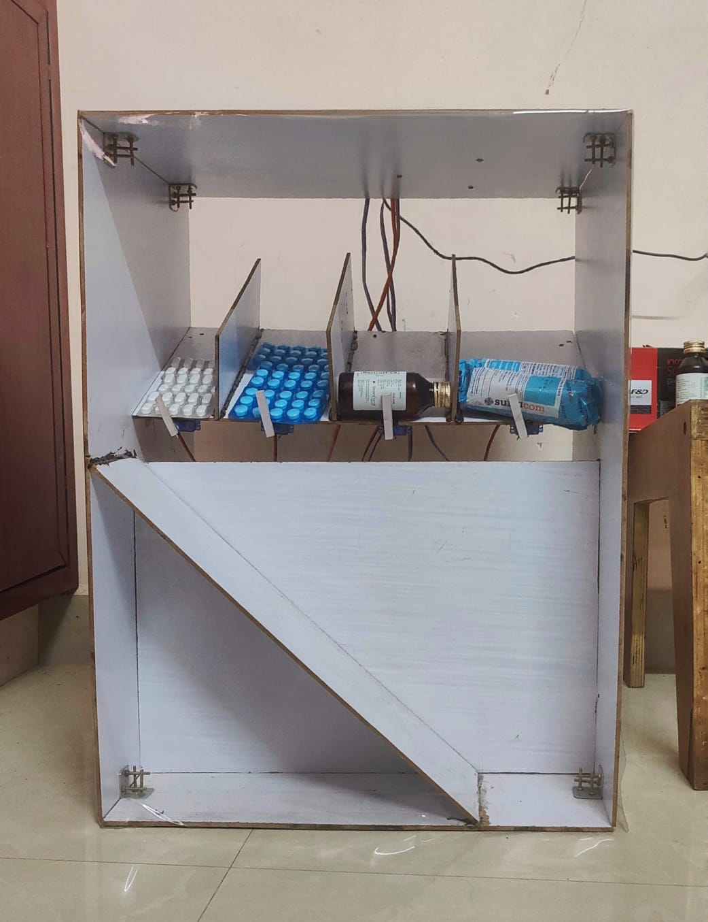

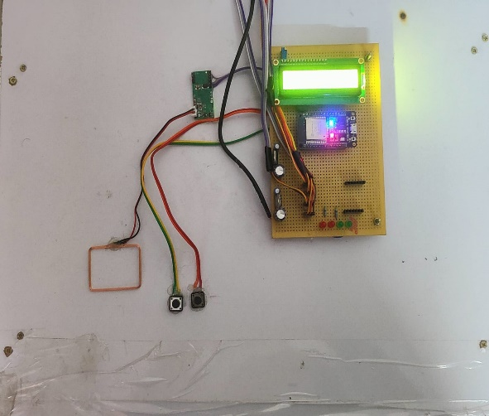

***figure 6.1. Prototype of the Proposed model***

The above figure 6.1. represents the experimental setup of our project.

**6.2. SOFTWARE SETUP**

An app is developed via “MIT App Inventor” called “**patient_prescription**”. This app is an encrypted platform in which the data of the patient is secured. The representation of the app is shown below

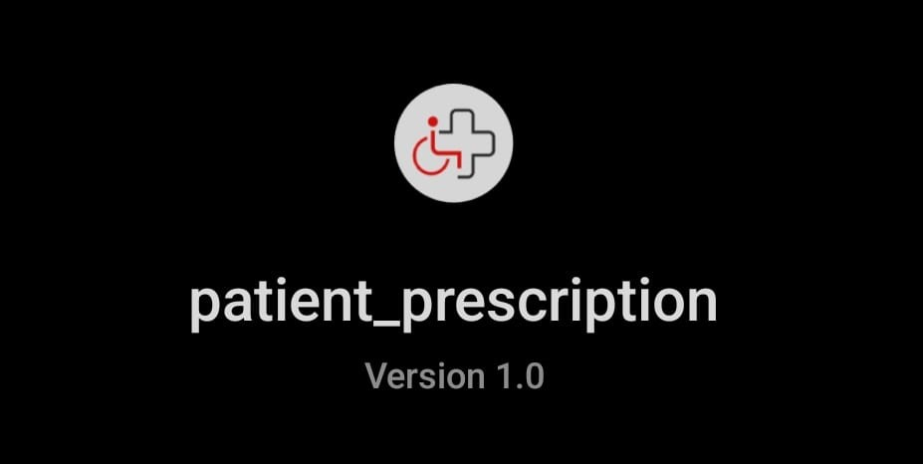

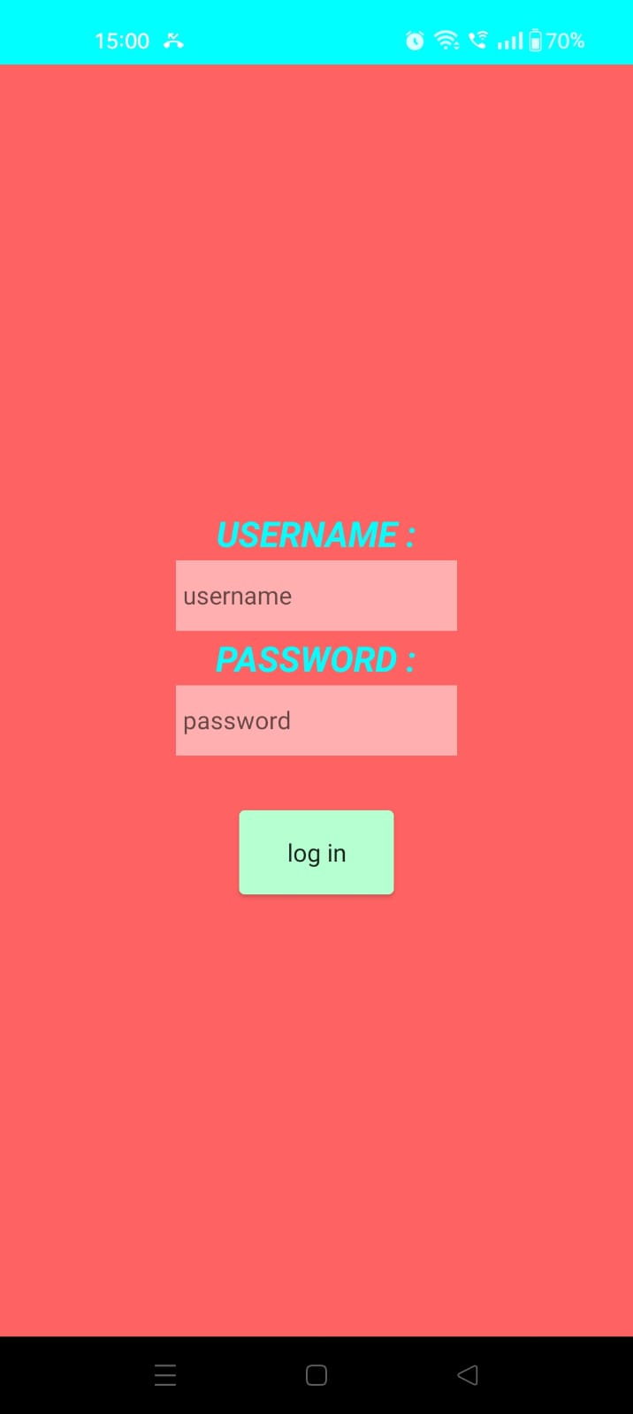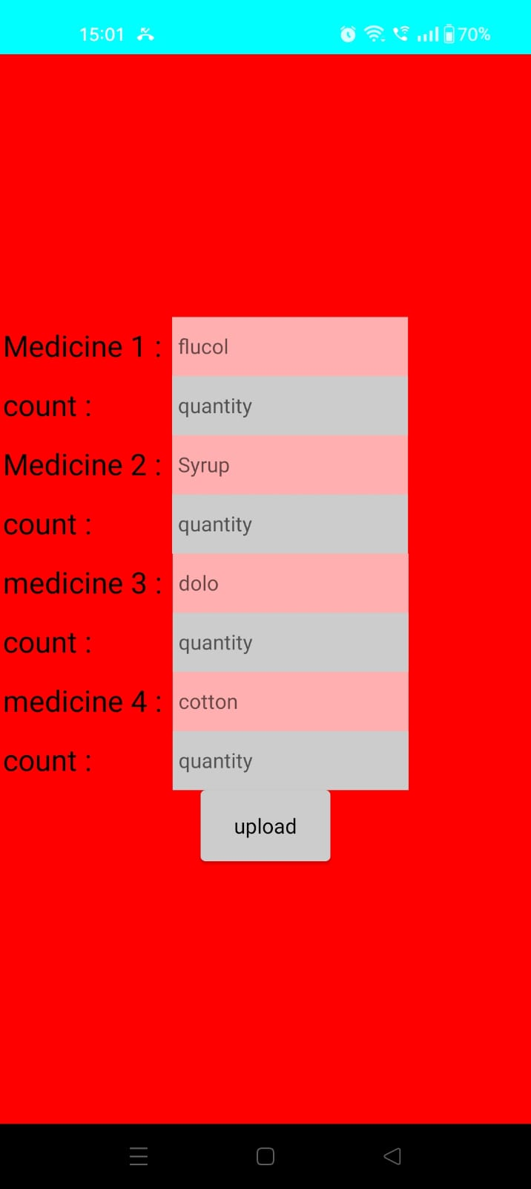

***figure 6.2. patient_prescription App***

**6.3. FINAL RESULTS OBTAINED**

The system consists of an ESP32, LCD, RFID reader, push buttons, LEDs, and servo motor. The ESP 32 is used for its dual-core processor mechanism and is controlled via a Wi-fi system. Two RFID reader cards, one for access and one for non-access, are used to fetch tablets. If a non-access card is shown, the device stops fetching the tablets, and a buzzer is emitted. An app called "Blynk IoT" is used for notifications, indicating successful tablet collection and unauthorized users. The notifications are shown below

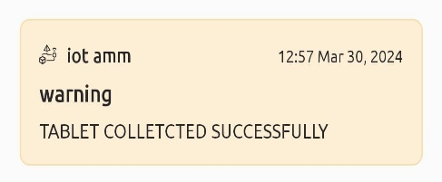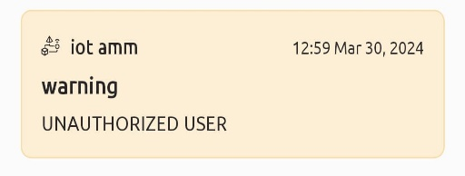

***figure 6.3. Notifications From The Blynk APP***

The tablet details are displayed on a 16x2 LCD, and a push-button is used to complete the payment process. The Servo motor dispenses the tablets, with green and red LEDs indicating successful payment. The ESP 32 retrieves the tablet's details from the app.

**6.4. COMPARISION BETWEEN EXISTING SYSTEM AND PROPOSED SYSTEM**

The traditional system is a bit insecure and there are no proper details about the person who purchased the medicines. In our proposed system, medicines can only be dispatched to a person having an RFID card. Our RFID tag will carry the digital theme of a doctor’s prescription. In most of the case common man is not aware to read the doctor’s prescription properly. Here due to digital prescription, they can easily know about the importance of medicines and the dosage of medicines on the right propositions. If our system is globalized, we can eliminate the middleman profits and fix up a global value for medicine throughout India. We strongly believe that dreams about digital India will be even more effective if we get practice in digital pharmacy. Our system can be even more precise and secure if we upgrade to biometric scanning to retrieve the data. The RFID card is the entire key to receiving the medicine for the patient. The person who carries the card can receive the medicine without having additional proof. We sometimes face insecurity due to this particular limitation. But this insecurity flaw can be eliminated by back through protocol through the registered mobile number. The person who lost the card can immediately use this back through the protocol to block his loyalty card to avoid such scenarios. If we have a network failure, we need a manpower team to solve the dispatching process. If the person has a damaged loyalty card also will be restricted from receiving the medicines. In such scenarios, the biometric method of handling the data will be a more secure and intelligent move.

**6.5. CONCLUSION**

1) Digitalization has been one of the most important trends in India over the past few years.

2) This rapid growth helps propel India to the forefront of digital and technological innovation, particularly leveraging the energies of the country's young population.

3) We strongly believe that our proposal would be a valuable key to digitalization.

4) Medical standards can be increased in our nation by following our few principles.

5) Our proposed system can also boost the GDP of our nation to some extent.

**6.6. FUTURE SCOPE**

1) Our system must be upgraded to bio-medical scanning devices.

2) This can create high security and avoid false play.

3) Online and UPI money portals must be introduced to the system.

4) Through this transaction portal service our system can be even more robust.

5) A general awareness medical log about the prescription must be added to the digital prescription.

6) This can create huge awareness among the public on medical drugs and their causes.

**REFERENCES**

1) Ashutosh D1. Gaur and Jasmin Padiya2, IJSR “A Study Impact of Digital India in Make in India‟ Program in IT and BPM Sector”, GLS University Transaction on Computer Science Engineering 2017.

2) A. Martina Franciska1 & Dr. S. Sahayaselvi2 IEEE “An overview on Digital Payment”, IJSCRT Transaction on Information Science Engineering 2019.

3) Aishwarya Raj Lakshmi1, and Ayaskanta Misra2 “RFID based Logistic Management System using IoT”, Research Gate Transactions on Neural Network, 2018.

4) Eric Becker1, Roman Arora2, and Vangelis Metsis3, “SmartDrawer: RFID-based smart medicine drawer for assistive environments”, Proceedings of the 2nd International Conference on Pervasive Technologies Related to Assistive Environments, January 2009.

5) Neethi1, Thammathip Piumsomboon2, Gun A. Lee2, and Mark Billinghurst2, Research Gate “A study of RFID Based Applications”, Research Gate Transactions on Augmented Reality in Computer Science Engineering, 2018.

6) Kubo1, A. Divija, G. V V N Vijayalakshmi, P. Vamsi, JARTMS “The Research of IoT based on RFID Tags”, IEEE Explore Transactions on Reality and Web Interface, 2021.

7) Neeta Chavan, Isha Chavan, Saakshi Karkera, “Design And Development of Smart Pill Dispenser” Sardar Patel International Conference on Industry 4.0 - Nascent Technologies and Sustainability for 'Make in India' Initiative, 2022.